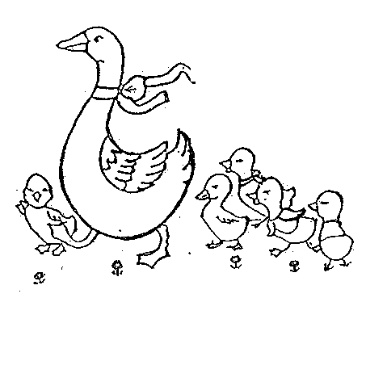
Mother Goose Nurseries
APPLICATION PROCEDURE

This application form should be completed and returned together with a non refundable registration fee of £30 (or £50 to register with all three Mother Goose Nurseries, indicating order of preference). This will guarantee your child a place on our waiting list(s).

Closures
MOTHER GOOSE NURSERIES are open “all year round” except for Bank Holidays, the week of Christmas and New Year and a Two-week summer holiday (usually the last week of July and first week of August). The exact dates are confirmed every January on the nursery calendar.

Spaces cannot be guaranteed if our register is full, however, we will place your child when a vacancy occurs. All places MUST include either a Monday or a Friday.

Deposit
A refundable deposit is due on enrolment of £300; this is refundable provided two full calendar month’s notice in writing is given when children are leaving. When a place is offered it is only secured once the deposit has been paid.

Fees
All fees are due and payable in advance on or before the 1st day of each new month. Monthly payments are by standing order only. The nursery may refuse admission to any child whose fees are not paid.

Opening times:
Greendale - 8am - 6.00pm
Upland and Waveney – 7.30am – 6.30pm

Although the Nursery’s day runs from 7.30 to 6.30 (6pm Greendale), we prefer the arrival of children from 8.00 am until 6.00 pm (5.30pm at Greendale), unless parents’ work commitments necessitate 7.30am to 6.30pm (6pm at Greendale). Parents should inform staff where this is to be the case.

Notice period:
When giving notice to the nursery to terminate a place, two full calendar months notice is required in order to have a full refund of your £300 deposit. Places will always terminate on the last day of the month. For example if you hand in your written notice in June, the last day of nursery would be the 31st August. Your deposit will be refunded to you via bank transfer to your chosen account up to 14 working days after your place terminates.

We admit children regardless of race, creed or national origin.

APPLICATION PROCESS FOR PARENTS

All applications for places should follow these stages:

- Application:
Completion of application form and payment of non-refundable registration fee places child on waiting list;
- Offer:
An offer of a place and a proposed starting date will be made by telephone or letter (preferred) when a place has become available, sometimes no more than 2 months before proposed starting date;
- Reservation:
Payment of a returnable deposit (currently £300): this reserves the place once an offer has been made;
- Giving Entry Profile (Admission) Forms:
This will be given to you once a placement is available and you have committed to this place by paying the relevant deposit.
- Enrolment:
Completion of the Entry Profile forms and signed agreement secures the reserved place and confirms the agreed starting date. Enrolment forms must be completed and returned on or before the child’s starting or settling in period commences. Wherever possible, this should be at least one week before commencement of the settling-in period/start date so that any care issues can be raised and clarified before the child begins at the nursery;
- Settling In:
Settling in arrangements should be made at the time of enrolment through guided negotiation with parents/carers and nursery manager or child’s key person. Agreed settling in times should take place, wherever possible, during the week before the start date and should not be charged;
- Trial Period:
The first two weeks that a child spends in nursery are considered as a trial period. At the end of this period, if it is found either by the parent/carer or by the nursery that the child is unable to settle into nursery life, then the agreement may be cancelled and the deposit (but not the fees for the period of attendance) returned.
Mother Goose Nurseries

APPLICATION FORM
If you complete and return this application form to your preferred nursery, together with a registration fee of £30 (or £50 for application to all three Mother Goose Nurseries), you will then be notified of an offer of a place. When one becomes available matching your requirements. A refundable deposit payment of £300 is required. Please note that it is often not possible to confirm a place until two months of the due starting date.
PROJECTED STARTING DATE:

CHILD’S AGE (IN MONTHS) AT PROJECTED START DATE:

Application for place at: Waveney Greendale Upland
(Please indicate order of preference if applying for all 3 nurseries)

ATTENDANCE:-

Full Time ( ) Part Time ( ): Mon Tues Weds Thurs Fri

For part time applications, circle required days/sessions. Minimum 2 full days, including a Monday or a Friday

Child's Name ____________________________________________

Male/Female (please circle)

Address ________________________________________________

_____________________________

Post Code ___________

Date of birth _____________________Home Tel. No _____________

E-mail ___________________ Mobile Tel. No _____________

Applicant’s relationship to child _________________________
Applicant’s name, position, and contact details- IF NOT the child’s legal parent or guardian-

Please provide the following information on people with whom the child lives:-
Parent/Carer name 1 _____________________________ Male/Female

Title_______ Mobile No _______________Daytime No _____________

Occupation_______________________

Email _______________________

Parent/Carer name 2 _____________________________ Male/Female

Title_______ Mobile No _______________Daytime No ____________

Occupation_______________________

Email _______________________

Brothers, sisters, or other adults living with the child:
__________________________________________________________

Previous childcare (if any):___________________________________

How did you hear about Mother Goose Nurseries? __________________

Signature of applicant ____________________ Date ________________
34 Waveney Ave SE15 3UB 0207 277 5951
Email: Waveney.manager@mothergoosenurseries.co.uk
65 Greendale Fields, off Wanley Road SE5 8JZ 0207 738 7700
Email: Greendale.manager@mothergoosenurseries.co.uk
248 Upland Road, SE22 ODN 0208 693 9429
Email: Upland.manager@mothergoosenurseries.co.uk
Web: www.mothergoosenurseries.com.uk

Office use only:

Reg Fee :…………....(Date) …………………. (Received by)........................

Depos..…………….. (Date) …………………. (Received by)..........................

Start date agreed: ……………………………..

